RAJOURI DISTRICT SCHOOLS DATA

1.International Higher Secondary School / International School Rajouri
- Type:Co-educational Senior Secondary School
- Establishment:1970
- Address:Ward No 9, Peer Kanjoo, Rajouri - 185131
- Contact:+91 1962 263258
- Email:israjour[at]gmail[dot]com
- Medium of Instruction:English
Infrastructure & Facilities
- Building:Pucca (permanent structure)
- Classrooms:Yes, with 30 computers
- Library:Yes, with approximately 3,000 books
- Playground:Yes
IMAGE : https://share.google/images/PIaoY07OBzYK6Okbd
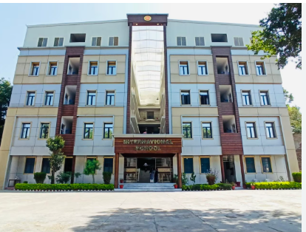

2. PM Shri Kendriya Vidyalaya BSF Campus Rajouri
- Year of Establishment:1980
- Affiliation:Central Board of Secondary Education (CBSE)
- Management:Kendriya Vidyalaya Sangathan
- Gender:Co-educational (Co-Ed)
- Medium of Instruction:English
- Streams Offered:Physics, Chemistry, Mathematics (PCM), Physics, Chemistry, Biology (PCB), Commerce, and Arts
- Classes Offered:Up to 12th grade
School Features & Facilities
- Quality Education:The school provides a child-centered and activity-oriented learning process to ensure the holistic development of students.
- Affordable Fees:Kendriya Vidyalaya offers education at nominal fees, making it accessible to a wide range of students, according to Careers360.
- Co-Curricular Activities:The school emphasizes not only academics but also sports and other activities, contributing to a well-rounded education.
IMAGE : https://share.google/images/eHFALnOxPgknz7hvS
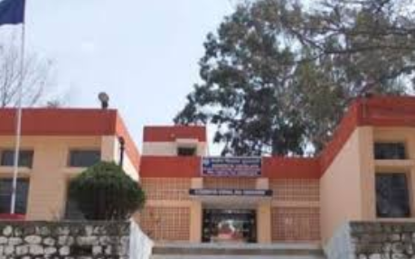

3. Garib Nawaz Public School
- Address:Dhanidhar, Rajouri, University Morh, Near Filter Plant, Rajouri
- Building Type:Private
- Classrooms:6
- Amenities:Computer-aided learning facilities, electricity, a library (with 50 books), a playground, and tap water for drinking.
- Staffing:The school has a staff with requirements listed for various teaching positions, including Math, Science, English, Social Science, and Hindi.
- Infrastructural Limitations:The school does not have ramps for the disabled.
IMAGE: https://share.google/images/KQE1lJcfbZbw6cEHA

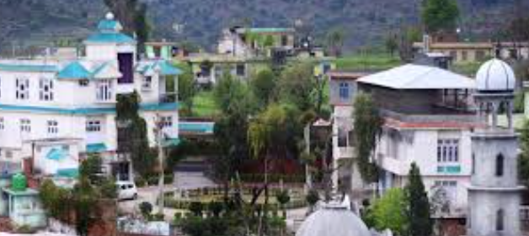

4. Jawahar Navodaya Vidyalaya (JNV) Rajouri
- Address:PM SHRI Jawahar Navodaya Vidyalaya, Village Kotranka, District Rajouri, Jammu & Kashmir, INDIA PIN - 185133
- Principal:Mr. S.K. Jain
- Emails:jnvrajouri2021@gmail.com, jnvrajouri222@gmail.com
- For Class VI and IX Admissions (JNVST Incharge):Mr. Subir Biswas, Mobile No.: 9749444464
Key Features
- Free Residential Education:JNV provides free accommodation, boarding, lodging, uniforms, and textbooks for all selected students.
- Co-Educational:The school is a co-educational institution.
- Residential:Both students and teachers stay on the campus, ensuring a 24/7 learning environment.
- Talent Focus:It aims to provide quality education to gifted children, predominantly from rural backgrounds.
- CBSE Affiliation:JNV schools are affiliated with the Central Board of Secondary Education (CBSE).
Admissions Process
- JNVST for Class VI:Admission to Class VI is through a district-level, open selection test conducted by the CBSE.
- Lateral Entry for Classes IX and XI:Vacant seats in these higher classes are filled through the Lateral Entry Selection Test (LEST), also conducted by the CBSE.
Fee Structure
- Classes VI to VIII:Tuition, hostel, food, uniforms, and textbooks are completely free.
- Classes IX to XII:A nominal fee of Rs. 600 per month is charged for the Vidyalaya Vikas Nidhi
Image: https://share.google/images/RFlLU9JqtoUbR8GUn
